Project Design Phase-II
Technology Stack (Architecture & Stack)

Date | 19 Feb 2026
Team ID | LTVIP2026TMIDS83753
Project Name | Weather-Based Prediction of Wind Turbine Energy Output: A Next-Generation Approach to Renewable Energy Management

Technical Architecture:
The Weather-Based Prediction of Wind Turbine Energy Output system follows a layered architecture that integrates a web-based user interface with a backend machine learning model. The architecture enables real-time prediction of wind energy output based on weather parameters provided by the user.
The system is designed to ensure scalability, maintainability, and real-time processing capability.
Example: AI-Powered Backend System for Real-Time Wind Energy Prediction
Reference: https://developer.ibm.com/patterns/ai-powered-backend-system-for-order-processing-during-pandemics/
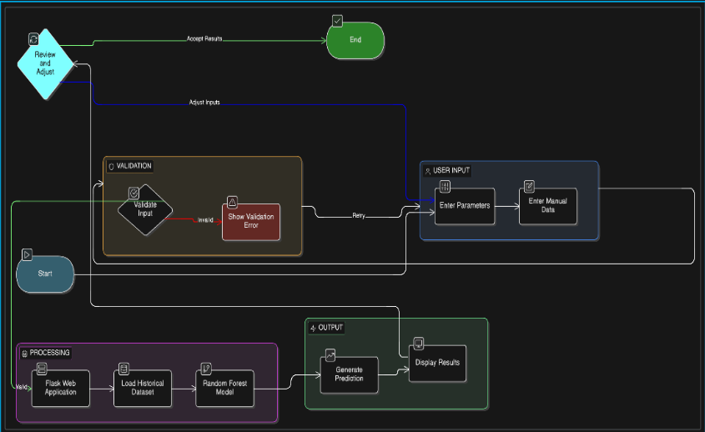
Guidelines:
The system should be designed using a layered architectural approach consisting of:
- Presentation Layer
- Application Layer
- Machine Learning Layer
The architecture should support real-time data processing and avoid batch execution to ensure immediate prediction results upon user input.

Table-1 : Components & Technologies:
S.No | Component | Description | Technology
 | User | Wind farm operator accessing the system | Web Browser
 | Web Dashboard | User interface for input and result display | HTML, CSS
 | Input Form | Collects wind speed and theoretical power | HTML Form
 | Web Server | Handles HTTP requests and routing | Flask (Python)
 | Backend Logic | Processes input and calls ML model | Python
 | Prediction Engine | Executes prediction logic | Scikit-learn.
 | Machine Learning Model | Predicts wind energy output | Random Forest Regression
 | Dataset | Historical wind turbine dataset | CSV File (T1.csv)
 | Runtime Environment | Runs the application locally | Local Flask Server (127.0.0.1:5000)

Table-2: Application Characteristics:
S.No | Characteristics | Description | Technology
 | Architecture Style | The system follows a layered architecture including Presentation, Application, and Machine Learning layers. | HTML, CSS, Flask, Scikit-learn
 | Processing Mode | The system performs real-time prediction immediately after user input without batch processing. | Flask, Python
 | User Interaction | Users can enter input values, view prediction  results, and modify inputs for recalculation. | HTML Forms, Flask
 | Input Handling | The system accepts manual data inputs such as wind speed and theoretical power. | HTML Forms, Python
 | Prediction Engine | The application uses a trained machine learning model to generate energy output predictions. | Random Forest (Scikit-learn)
 | Data Management | Historical wind turbine data is used to train the prediction model. | CSV File (T1.csv), Python
 | Deployment Model | The application runs locally on a development server. | Flask Local Server (127.0.0.1:5000)
 | Error Handling | Basic validation ensures that required fields are filled and values are numeric. | HTML Validation, Python
 | Scalability | The system can be extended to cloud deployment and advanced ML models. | Flask, Cloud Platforms (Future)
 | Extensibility | Future integration of weather APIs and LSTM models is possible. | Future integration of weather APIs and LSTM models is possible.

References:
https://c4model.com/
https://developer.ibm.com/patterns/online-order-processing-system-during-pandemic
https://www.ibm.com/cloud/architecture
https://aws.amazon.com/architecture
https://medium.com/the-internal-startup/how-to-draw-useful-technical-architecture-diagrams-2d20c9fda90d

